JUMP into Steady Beat!
Lesson by: Katie Grace Miller

Learning Targets:

Students will demonstrate the steady beat in movement and on instruments.
Students will show the Bar Basics in Orff technique.

Materials:

Book: JUMP! By: Scott M. Fischer, published by Simon & Schuster
Instruments: rhythm sticks, Orff instruments

Lesson:

- Learn the melody below to read the book to on each page.

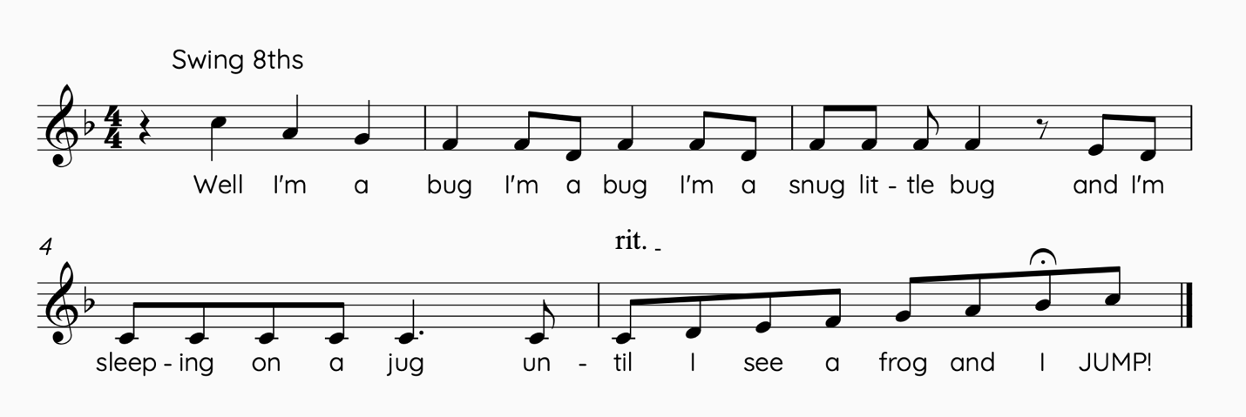

- The first measure should be read at a rubato to let the kiddos get ready for the steady beat that they should feel.
- Ask students to do a “steady beat bop” where they squat with feet on the floor and they “bop” up and down at the knees and then each time the melody comes to the end they catapult off the floor for a super high JUMP on the word! Continue this movement throughout the book.

Transfer to Orff instruments:

- Put your Orff in F pentatonic and ask students to choose 2 notes to play the steady beat on. I tell my students to wait until I sing the animal and then begin, that way they aren’t playing on the rubato.
- On the word “until” students should go into silent position and wait for the fermata and then find two new notes to play on the word JUMP! Then stay on those 2 new notes for the next verse and continue the pattern.
Bonanza Bonus:

This is an excellent opportunity to remind your students to look at the conductor. They are staying on the same two notes so as soon as they choose those notes encourage them to look at you so that you can cut them off on the word “until” and then also see and anticipate when the word JUMP, will happen!

Extension:

You could find a Fermata Friend! Ask a student to come out and hold the fermata up for each time the theme happens and they decide how long the fermata will last!

Assessment:

The theme is very constant so this lesson is a great opportunity not only to see who has the steady beat, but also go around and make sure which students are getting down those Bar Basic Techniques to make sure that they are correct and allows you to do some individual corrections if needed.

